

**Introduction**

The aim of this lab assignment is to design a DC power supply. For this purpose we have to assemble a rectifier circuit on the output of a transformer. It also involve the calculation of different components used so the DC supple contains lesser ripples.

The DC power supply has wide applications in the modern world. Every day we use Mobile charger , Laptop Charger , Ring bell, TV etc. All these equipments require DC power supply to operate.

**Bill of Material**

1. Fritzing beta software
2. PC or Laptop
3. 4 units of 1N4001 diode
4. 2 unit of 100 uF electrolytic capacitor
5. 1 unit of 1 uF electrolytic capacitor
6. 1 unit of 1000 ohms resistor
7. 1 unit of 240 ohms resistor
8. 1 unit of LM317 adjustable regulator IC
9. 1 unit of 220/12 Vrms.0.75 Amps transformer

**10)**1 unit of breadboard

**11)**1 unit of AC power plug

**12)**Connecting wires

**Circuit Design**

**Transformer:**

A Transformer is a static piece of equipments used either for raising or lowering the voltage of an ac supply with a corresponding decrease and increase in current. It essentially consist of two windings primary and secondary, wound on a common laminated magnetic core as shown in figure.

N1: no. of turns in primary coil

N2: no. of turns in secondary coil

If N1< N2 :- Step-up transformer

N1> N2 :- Step-down transformer

The following points may be noted carefully:-

The transformer action is based on the law of electromagnetic induction.

There is no electrical/physical connection between the primary & secondary windings. The ac power transferred from primary to secondary through magnetic flux.

There is no change in frequency i.e. output power has the same frequency as the input power The losses that occur in transformer are:

Core losses- eddy current & hysteresis losses.

Copper losses-in the resistance of a winding.

Relation b/w voltages and no. of turns is:

(V1/V2)=(N1/N2)

**Checking of Transformer:-**

**1. Without connecting power supply:-**

1. **Insulation of Cu wire(short circuit) :-** if the circuit is short than its

resistance will be “0”.

1. **Test for open circuit :-** if the winding is break (open) from anywhere than itwill show very high “infinite” resistance.

**2.Using power supply:-**

**Rating error:-** It is to verify whether output of a transformer is according toits rating(voltage and current) or not**.**

It is identified by measuring Voutput and Ioutput using multimeter.

**The** transformer which we have used is given bellow

*type:- 9-0-9 ;Current rating= 500mA*

Readings :- at no load condition

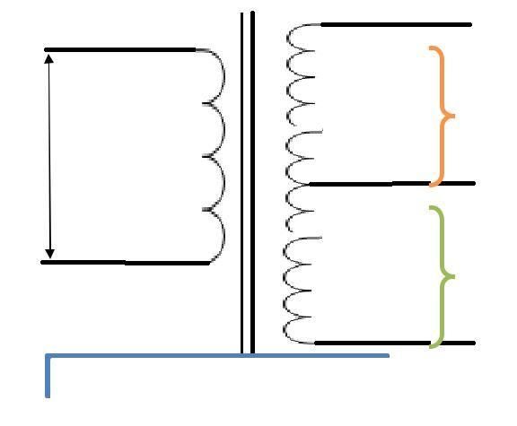

|  |  |  |
| --- | --- | --- |
|  |  | **Vrms=9.59V** |
|  |  | **Vp-p=27.20V** |
| **AC Supply** |  |
| **230v/50Hz** |  |  |
|  |  |
|  |  |  |
|  |  |  |
|  |  | **Vrms=9.67V** |
|  |  | **Vp-p=27.20V** |
|  | **Primary winding** |  |
|  |  |

*Fig.1.2: Transformer output observations*

1. To find voltages at full load condition.
2. First we have to find appropriate load value.
3. Load load value is such that the current from the load is nearly 1Amp.
4. IV. 1Amp current is flowing at 18.2Ω load.

|  |  |  |
| --- | --- | --- |
| **Vrms=17.5V** | **.** | **Vp-p=48.8V** |

The following readings are taken through the transformer:

1. Resistance of primary winding= 127.8Ω
2. Resistance of secondary winding= 0.9 Ω/0.9 Ω (measured from different terminals 9-0-9)
3. Secondary windings (at full load)

Readings:- at full load condition

If we very the load resistance and set current at 1Amp. Than that value of resistance is the value of full load.

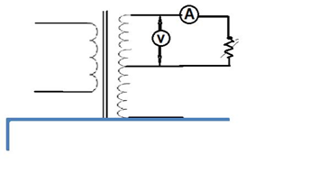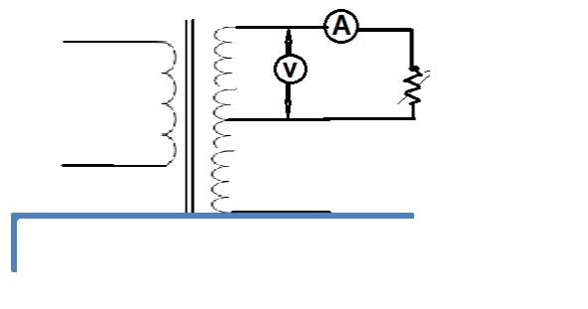

**R**L= **9.2Ω**

*Fig.1.3: circuit to find value of RL*

|  |  |
| --- | --- |
| at I(current at output of transformer)=1 Amp |  |
| RL=**9.2** **Ω ; total RL=18.4 Ω ; V=8.75V** |  |
| Secondary windings (at no load): |  |
| Vrms= 27.2/2√2= 9.6453V |  |
|  |

Total Vrms = 19.2906V

**Rectification:**

The diode is an ideal and simple device to convert AC into DC. The process is called rectification.

**Full Wave Rectifier**

A [Full Wave Rectifier Circuit](http://www.amazon.in/s/?field-keywords=POWER%20ELECTRONICS%20HANDBOOK%2C%20Third%20Edition) produces an output voltage or current which is purely DC or has some specified DC component. Full wave rectifiers have some fundamental advantages over their half wave rectifier counterparts. The average (DC) output voltage is higher than for half wave, the output of the full wave rectifier has much less ripple than that of the half wave rectifier producing a smoother output waveform.

*The Full Wave Bridge Rectifier*

Another type of circuit that produces the same output waveform as the full wave rectifier circuit above, is that of the **Full Wave Bridge Rectifier**. This type of single phase rectifier uses four individual rectifying diodes connected in a closed loop “bridge” configuration to produce the desired output. The main advantage of this bridge circuit is that it does not require a special centre tapped transformer, thereby reducing its size and cost. The single secondary winding is connected to one side of the diode bridge network and the load to the other side as shown below.

**The Diode Bridge Rectifier:-**The four diodes labelledD1toD4are arranged in “seriespairs” with only two diodes conducting current during each half cycle

The diode is an ideal and simple device to convert AC into DC. The process is called rectification.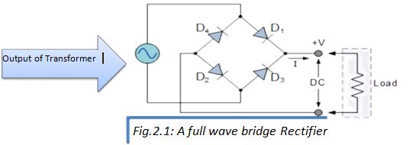

**Working of Full Wave Bridge Rectifier:-**

The **Positive Half-cycle**. During the positive half cycle of the supply,

diodes **D1** and D2conduct in series while diodes D3 and D4 are reverse biased and the current flows through the load as shown below.

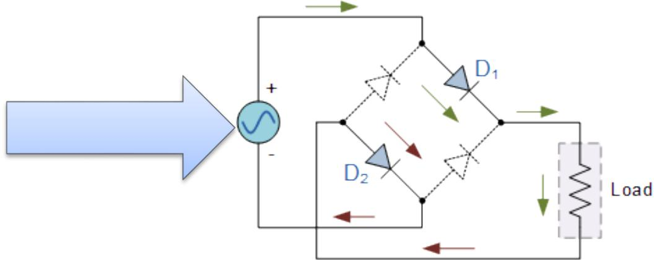

The Negative Half-cycle During the negative half cycle of the supply, diodes D3 and D4 conduct in series, but diodes D1 and D2 switch “OFF” as they are now reverse biased. The current flowing through the load is the same direction as before.

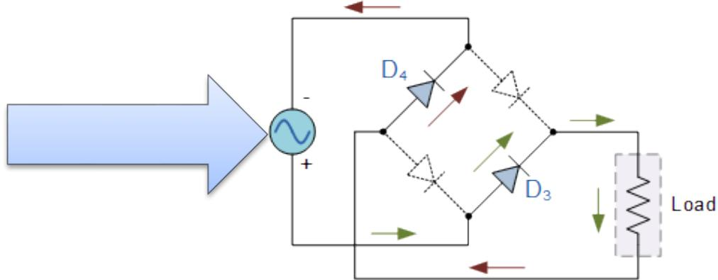

Output of Transformer

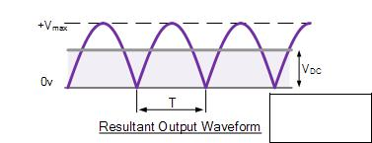

T=10ms. (because frequency is 50 Hz.)

frequency is 50 Hz)



**CAPACITOR FILTER**

We saw in the previous section that the single phase half-wave rectifier produces an output wave every half cycle and that it was not practical to use this type of circuit to produce a steady DC supply. The full-wave bridge rectifier however, gives us a greater mean DC value (0.637 Vmax) with less superimposed ripple while the output waveform is twice that of the frequency of the input supply frequency. We can therefore increase its average DC output level even higher by connecting a suitable smoothing capacitor across the output of the bridge circuit.

**Formulas to find capacitor value**:-

There are so many ways to find capacitor values . the formulas mostly used are:-

1. Q=CV

C=I**L/**2.f. ∆.V

OR

1. Q=CV

C=Q/∆V

C=I.td/∆V {because Q=I.t}

Now we have to find values of I(current) , td(discharging time period) and ∆V(ripple voltage) .

For current:

I = current rating of transformer

∆V(ripple voltage):

∆V= Vm-value of voltage assumed in input of regulator which

Is sufficient to give required output

**Voltage Regulator**

**Designing of regulated DC Power Supply using adjustable Voltage Regulator IC-LM317:-**

Electrical properties of LM317:-

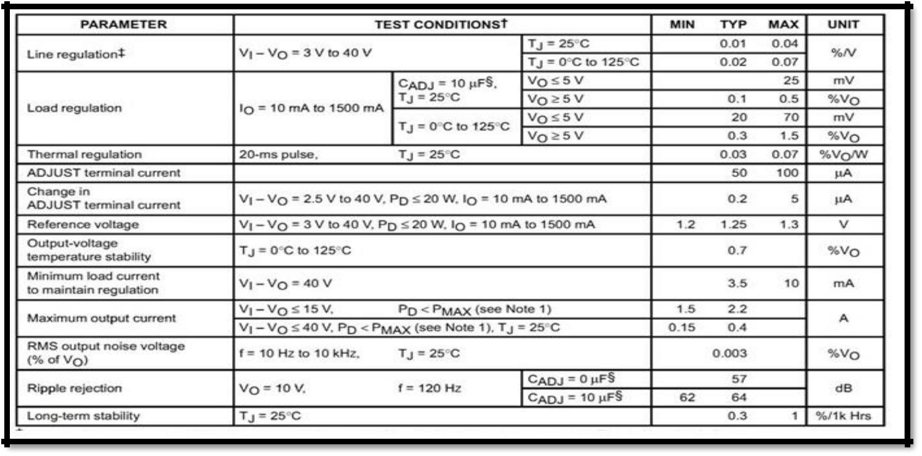

to calculate the values of R1 & R2:-



IL= 20mA

|  |  |  |
| --- | --- | --- |
| Vref.= 1.2V |  | (values from Datasheet) |
|  | |  |
| Iadj= 100µA | | |
| R1= Vref/IL | =1.2V/10mA | |

R1=240Ω

For R2



Voutput= Vref(1+R2/R1)+(Iadj*R2)

5V=1.25(1+R2/240)+(100 µA *R2) R2=706.21 Ω

***Formulas:-***

***Load Regulation=[(V no load-V full load)/ V full load]*100 Line Regulation=(∆Voutput/∆Vinput)*100***

***%/Volt= {[∆Voutput/Voutput]/ ∆Vinput}*100***

**Typical load regulation is 0.1%.**

**Line Regulation:-** If the line voltage or supply voltage is varied butthe output voltage remain constant.

The supply voltage is varied through an Auto Tranformer.

* It can vary the supply voltage from 0 to 260 Volt.
* Carbon Brush with spring contact makes the voltage step-up or step-down.

“Line regulation at no load”

**Line Regultion in %/Volt= {[∆Voutput/Voutput]/ ∆Vcapacitor}*100**

**Typical line regulation is 0.01%.**

Because we are not able to set the same temperature and other testing condition for the measurement so the outputs will not follow exact datasheet of LM317.

**Power Calculation**

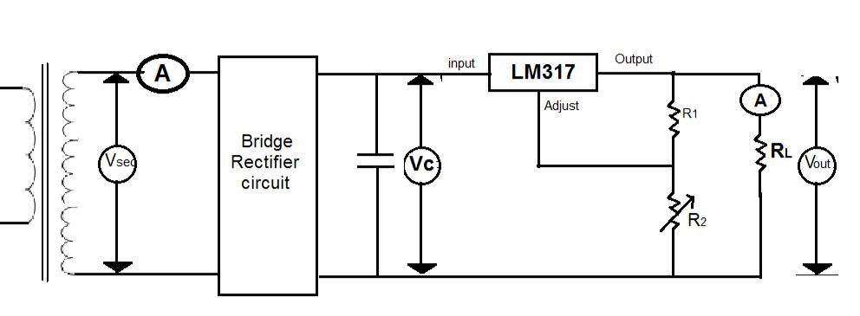

**INPUT POWER:**

Pi=Isec*Vsec

OUTPUT POWER:

Pi=Io*Vo

Power consumed by regulator:

Preg= Io* (Vc-Vo)

Power consumed by rectifier:

Px= Pi-(Po+Preg)

**Circuit Diagram**

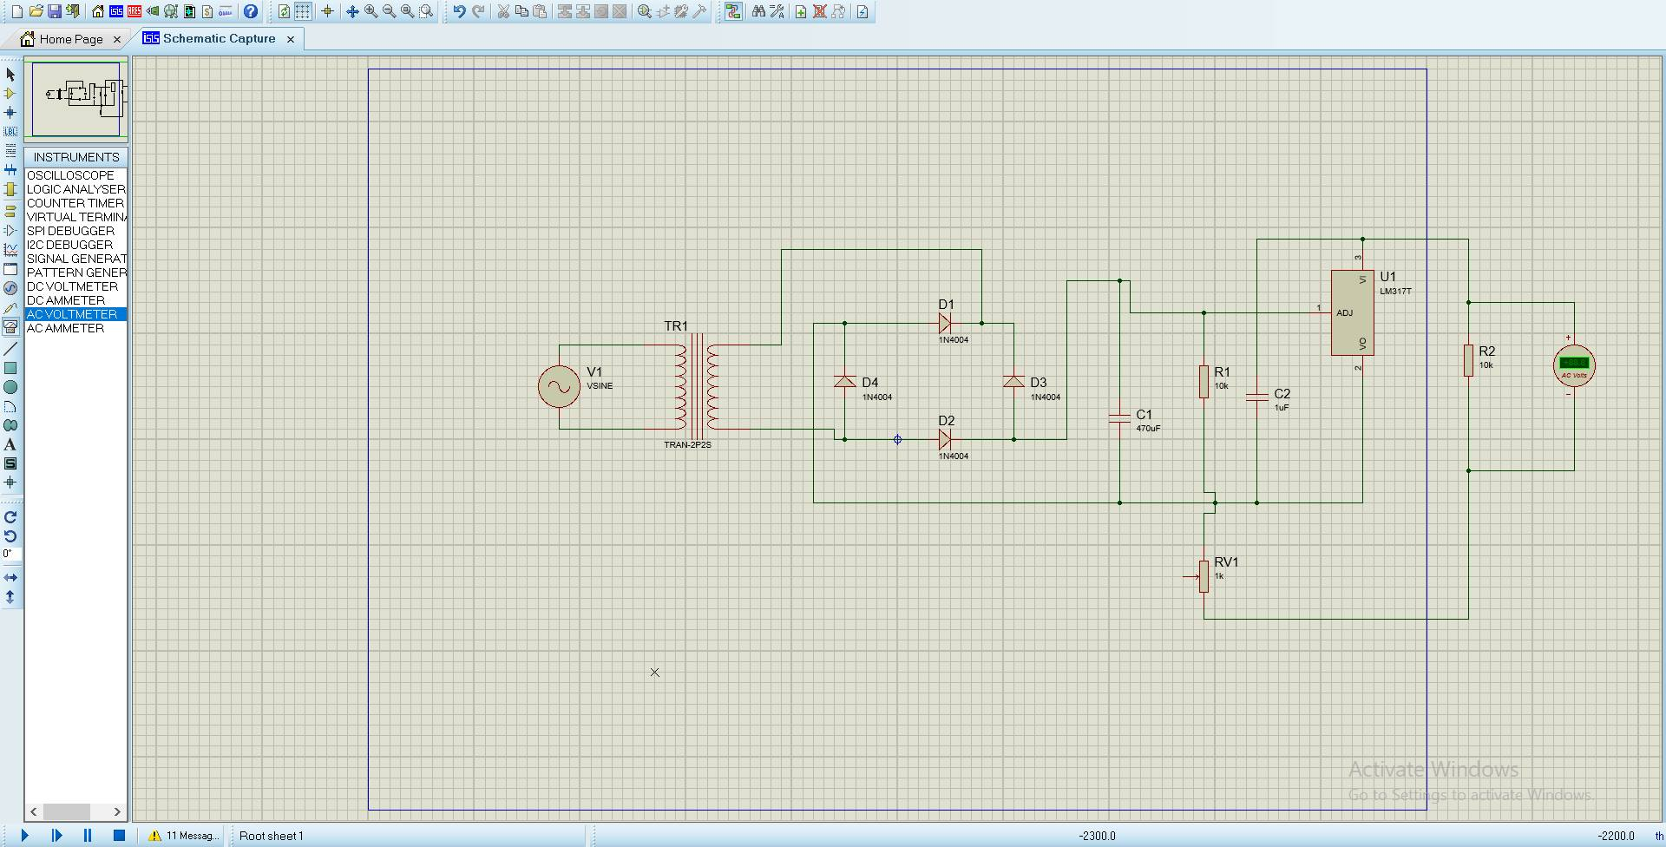

**T*****POWINPUT*** *POWER*